UNIT 4
LAB EXPERIMENTS
D Bhavitha(192511152)
Q1:program

@relation mall_customers
@attribute CustomerID numeric
@attribute Gender {Male,Female}
@attribute Age numeric
@attribute Annual_Income numeric
@attribute Spending_Score numeric
@data
1,Male,19,15,39
2,Male,21,15,81
3,Female,20,16,6
4,Female,23,16,77
5,Female,31,17,40
Output:
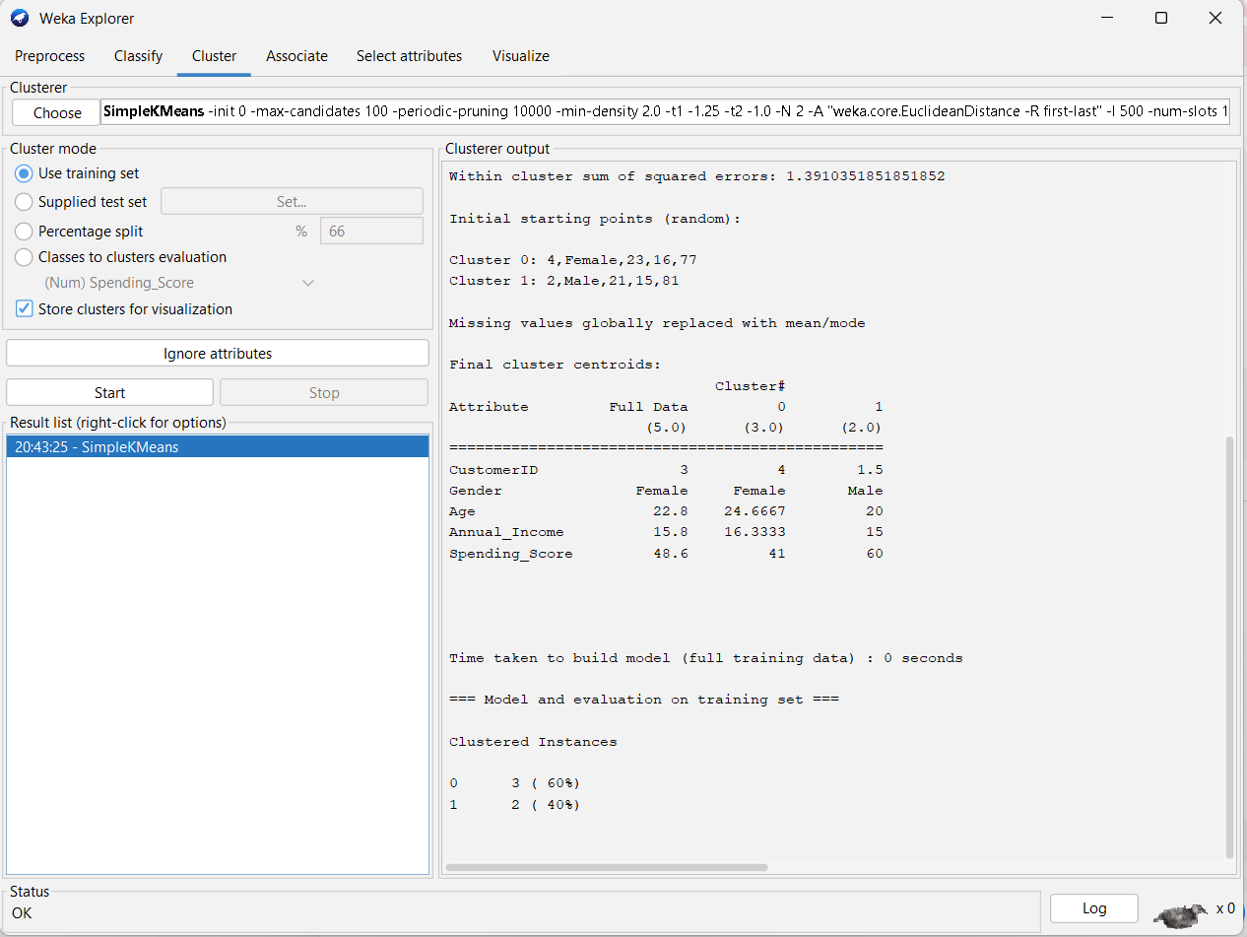
Q2:program
EmployeeID,Gender,Age,Salary,Credit
111,Male,28,150000,39
222,Male,25,150000,27
333,Female,26,160000,42
444,Female,25,160000,40
555,Female,30,170000,64
666,Male,29,200000,72
Output:
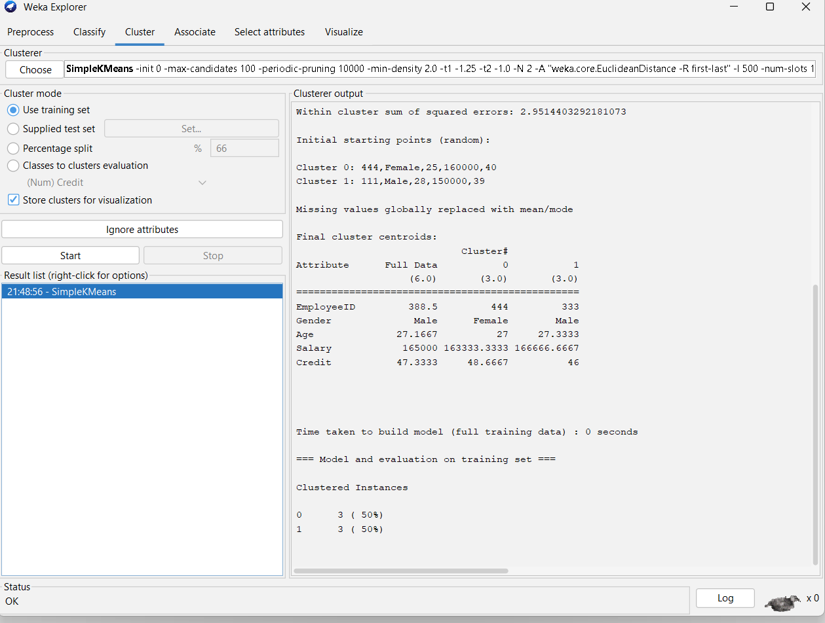
Q3:program
@relation playtennis

@attribute Outlook {Sunny,Overcast,Rain}
@attribute Temperature {Hot,Mild,Cool}
@attribute Humidity {High,Normal}
@attribute Windy {False,True}
@attribute Play_Tennis {Yes,No}

@data
Sunny,Hot,High,False,No
Sunny,Hot,High,True,No
Overcast,Hot,High,False,Yes
Rain,Mild,High,False,Yes
Rain,Cool,Normal,False,Yes
Rain,Cool,Normal,True,No
Overcast,Cool,Normal,True,Yes
Sunny,Mild,High,False,No
Sunny,Cool,Normal,False,Yes
Rain,Mild,Normal,False,Yes
Sunny,Mild,Normal,True,Yes
Overcast,Mild,High,True,Yes
Overcast,Hot,Normal,False,Yes
Rain,Mild,High,True,No
Output:
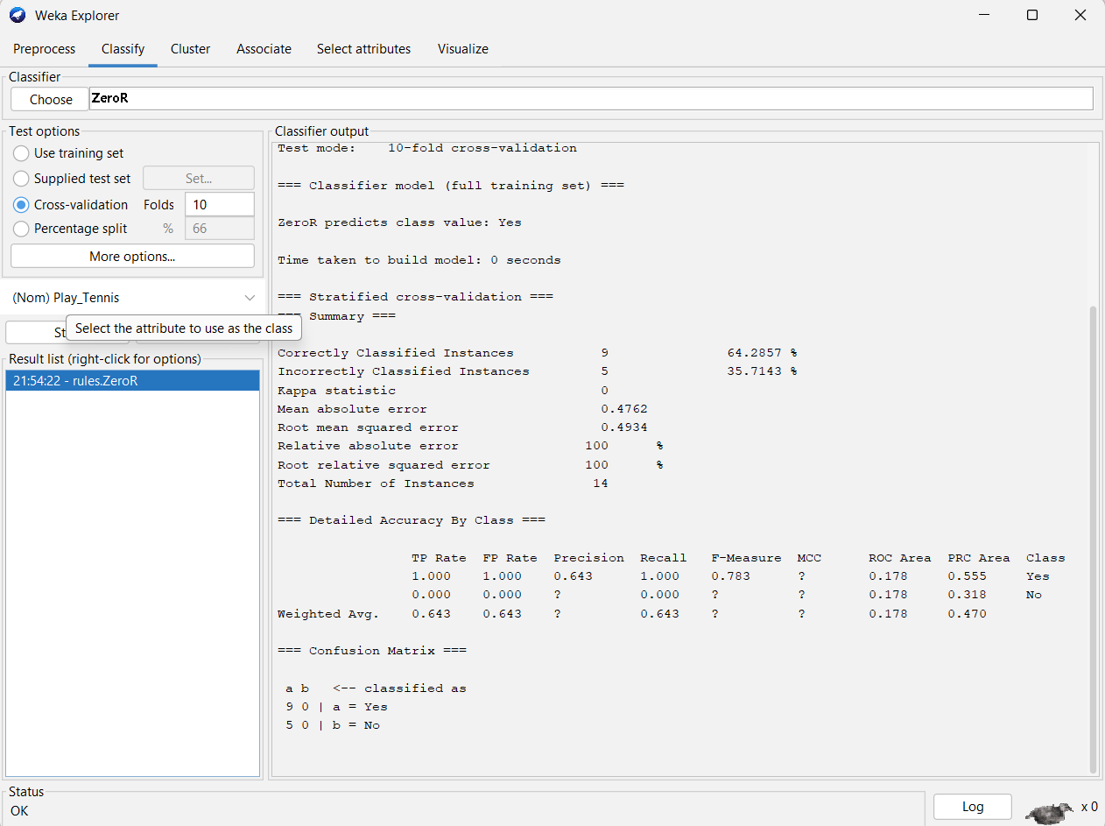
Q4:program
@relation vegetarian_data

@attribute Person_ID {P1,P2,P3,P4,P5,P6,P7,P8,P9,P10}
@attribute Name {A,B,C,D,E,F,G,H,I,J}
@attribute Food_Type {Vegetarian,Non_Vegetarian}

@data
P1,A,Vegetarian
P2,B,Non_Vegetarian
P3,C,Vegetarian
P4,D,Non_Vegetarian
P5,E,Vegetarian
P6,F,Vegetarian
P7,G,Non_Vegetarian
P8,H,Vegetarian
P9,I,Non_Vegetarian
P10,J,Vegetarian
Output:
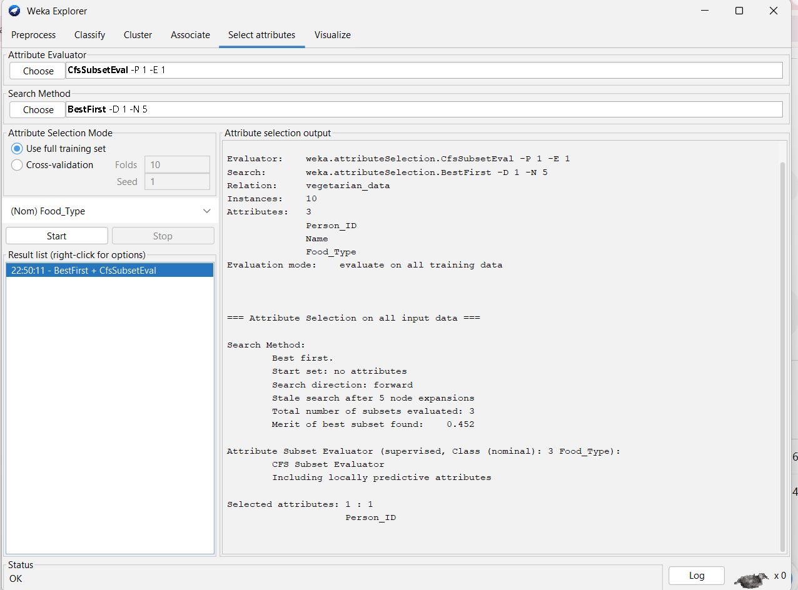
Q5 program:
Mobile_Phones_Sold,Money
4,12
1,5
5,13
7,19
10,31
2,7
50,153
25,72
90,275
36,110
Output:
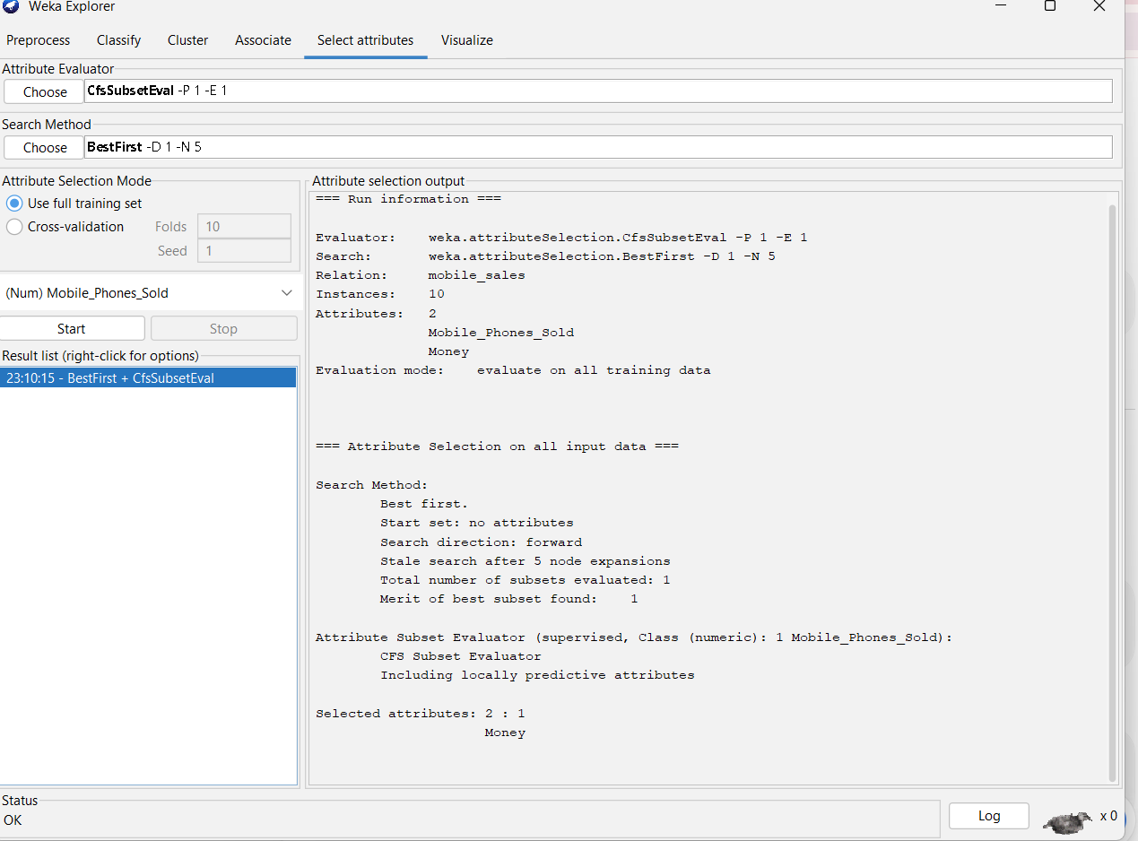
Q6 program:
@relation market_basket

@attribute Bread {yes,no}
@attribute Cheese {yes,no}
@attribute Egg {yes,no}
@attribute Juice {yes,no}
@attribute Milk {yes,no}
@attribute Yogurt {yes,no}
@data
yes,yes,yes,yes,no,no
yes,yes,no,yes,no,no
yes,no,no,no,yes,yes
output:
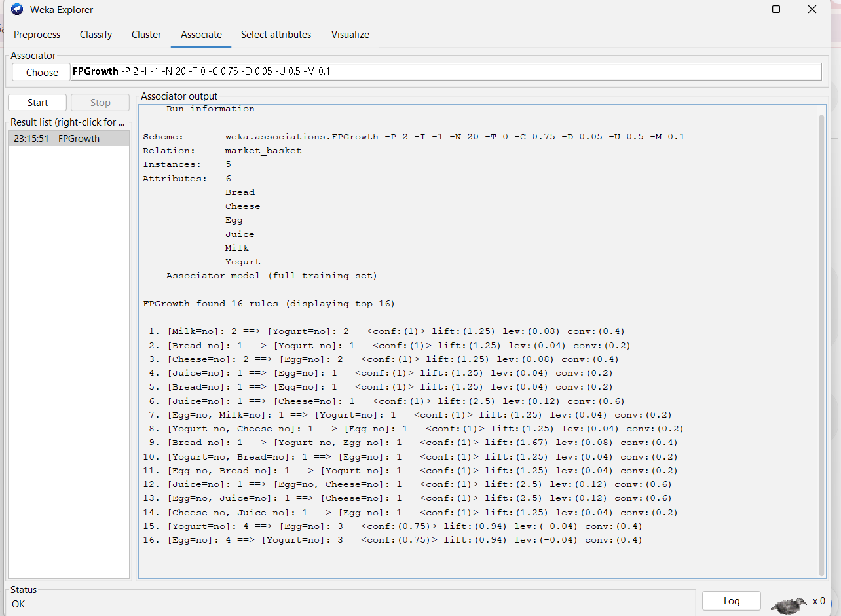
Q7 program:
@relation diabetes
@attribute Pregnancies numeric
@attribute Glucose numeric
@attribute BloodPressure numeric
@attribute BMI numeric
@attribute Age numeric
@attribute Diabetes {Yes,No}
@data
1,85,66,26.6,31,No
8,183,64,23.3,32,Yes
1,89,66,28.1,21,No
0,137,40,43.1,33,Yes
5,116,74,25.6,30,No
3,78,50,31.0,26,Yes
10,168,74,38.0,34,Yes
2,90,68,24.5,27,No
4,110,72,34.1,29,No
7,150,78,35.2,41,Yes
6,120,70,30.5,35,No
9,175,80,39.0,45,Yes
2,95,60,22.5,24,No
5,140,75,33.6,37,Yes
3,100,65,28.0,28,No
8,160,72,36.5,42,Yes
1,88,62,24.0,23,No
4,130,70,32.2,31,Yes
6,125,68,29.5,36,No
7,155,76,37.1,40,Yes
Output:
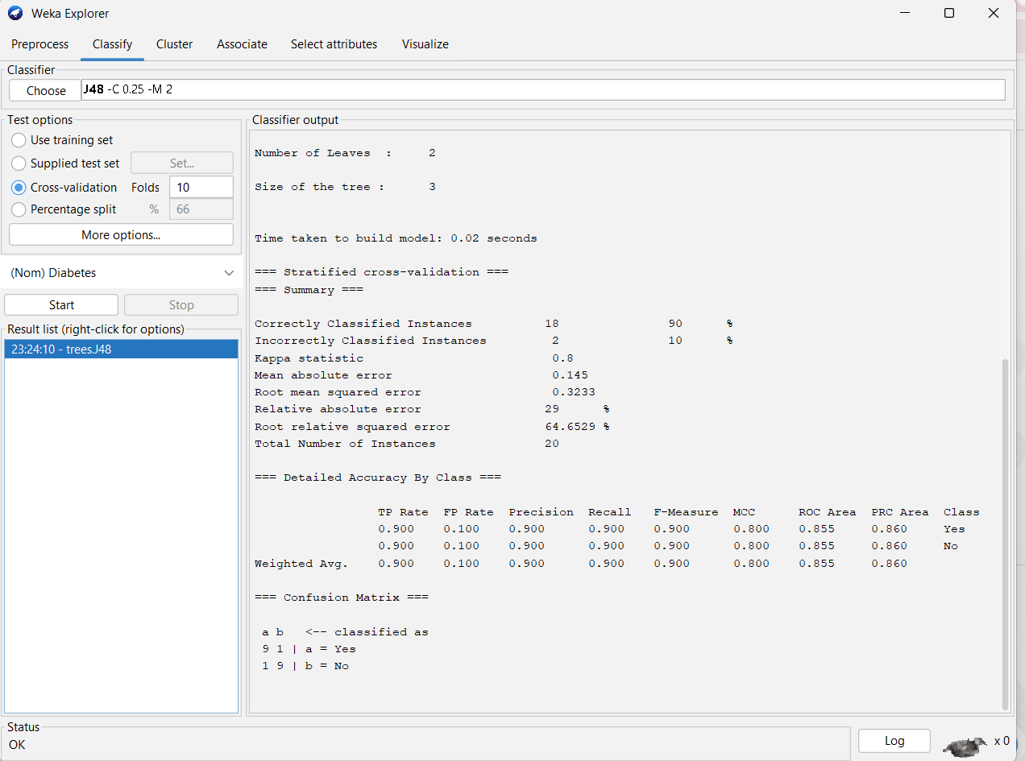
Q8 program:
# Marks data
marks <- c(55,60,71,63,55,65,50,55,58,59,
61,63,65,67,71,72,75)

# Sort the data
marks <- sort(marks)

print("Sorted Marks:")
print(marks)

# --------------------------------
# (a) Equal-Frequency Partitioning
# --------------------------------

n <- length(marks)

# Divide into 3 approximately equal groups
bin1 <- marks[1:6]
bin2 <- marks[7:11]
bin3 <- marks[12:17]

print("Equal-Frequency Bins:")
print(bin1)
print(bin2)
print(bin3)

hist(marks,
breaks = c(49, 58, 65, 76),
main = "Equal-Frequency Partitioning",
xlab = "Marks",
ylab = "Frequency")

# --------------------------------
# (b) Equal-Width Partitioning
# --------------------------------

min_marks <- min(marks)
max_marks <- max(marks)

width <- (max_marks - min_marks) / 3

breaks <- c(min_marks,
min_marks + width,
min_marks + 2 * width,
max_marks)

print("Equal-Width Breaks:")
print(breaks)
hist(marks,
breaks = breaks,
main = "Equal-Width Partitioning",
xlab = "Marks",
ylab = "Frequency")

# --------------------------------
# (c) Clustering
# --------------------------------

set.seed(123)

k <- kmeans(matrix(marks), centers = 3)
print("Cluster Centers:")
print(k$centers)
print("Cluster Assignment:")
print(k$cluster)
# Plot clustered data
plot(marks,
k$cluster,
main = "K-Means Clustering",
xlab = "Marks",
ylab = "Cluster",
pch = 19)

# Histogram of clustered data
hist(marks,
breaks = 3,
main = "Histogram - Clustering",
xlab = "Marks",
ylab = "Frequency")
output:
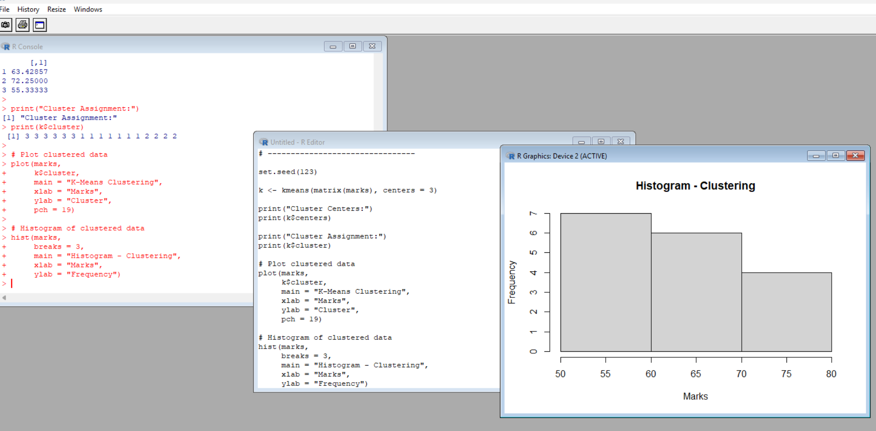
Q9 program
@relation person_classification
@attribute Height numeric
@attribute Weight numeric
@attribute Gender {Male,Female}
@data
185,75,Male
190,90,Male
182,70,Male
175,85,Male
170,90,Male
165,70,Female
160,65,Female
178,75,Female
172,78,Female
180,80,Female
168,85,Male
176,82,Male
Output:
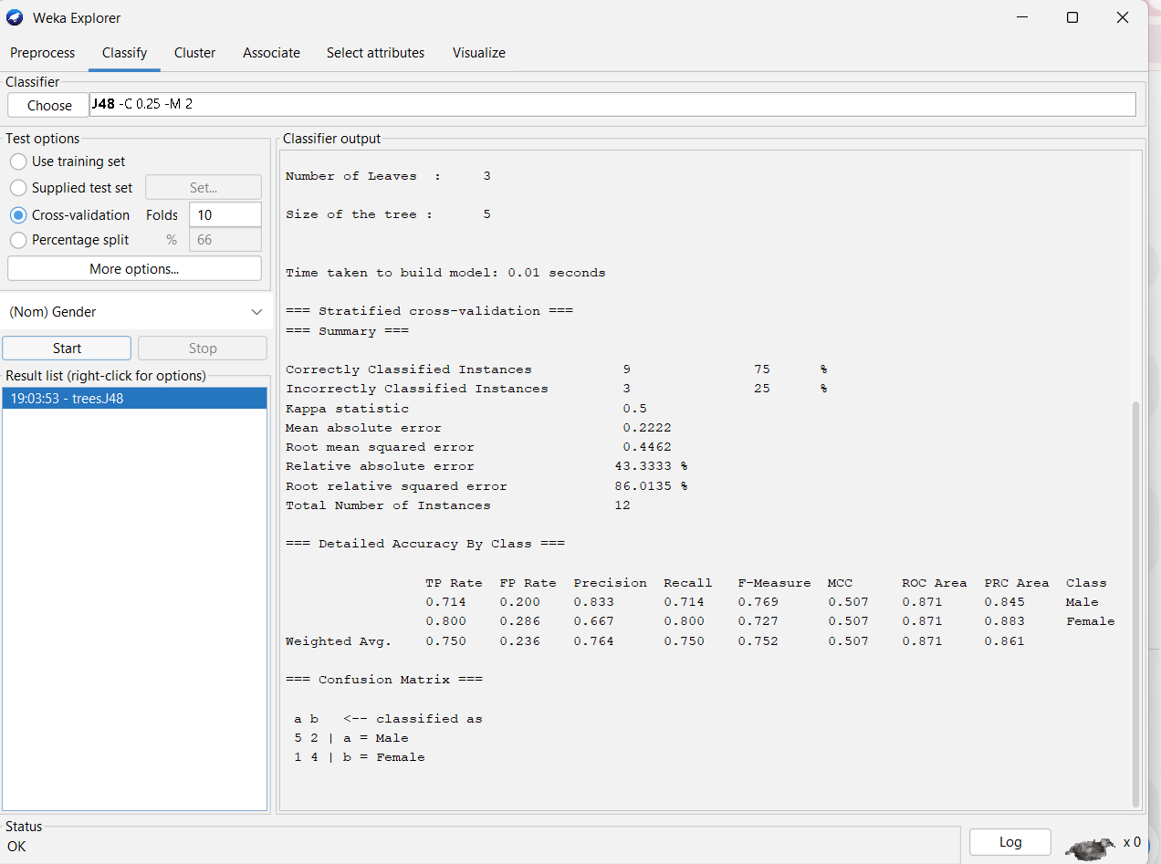
Q10 program
@relation electronic_items
@attribute SONY {yes,no}
@attribute BPL {yes,no}
@attribute LG {yes,no}
@attribute SAMSUNG {yes,no}
@attribute ONIDA {yes,no}
@data
yes,yes,yes,no,no
no,yes,no,yes,no
no,yes,no,no,yes
yes,yes,no,yes,no
yes,no,no,no,yes
no,yes,no,no,yes
yes,no,no,no,yes
yes,yes,yes,no,yes
yes,yes,no,no,yes
output:
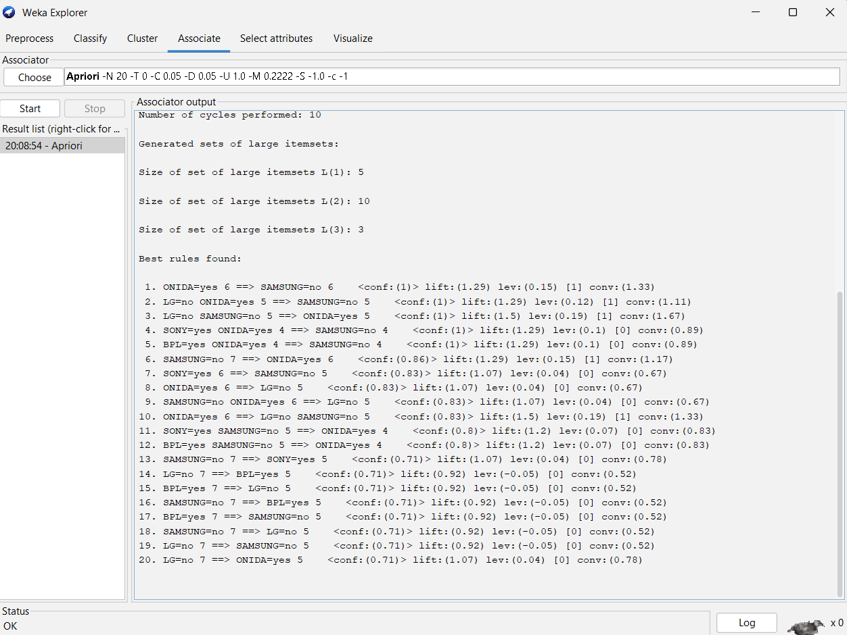
Q11 program:
# Strike rates
x <- c(100, 70, 60, 90, 90)
# (a) Min-Max Normalization
min_max <- (x - min(x)) / (max(x) - min(x))
print("Min-Max Normalization")
print(min_max)

# (b) Z-Score Normalization
mean_x <- mean(x)
sd_x <- sd(x)

z_score <- (x - mean_x) / sd_x

print("Z-Score Normalization")
print(z_score)

# (c) Z-Score using Mean Absolute Deviation
mad_value <- mean(abs(x - mean_x))

z_mad <- (x - mean_x) / mad_value

print("Z-Score using MAD")
print(z_mad)
# (d) Decimal Scaling Normalization
j <- ceiling(log10(max(abs(x)) + 1))
decimal_scaling <- x / (10^j)
print("Decimal Scaling Normalization")
print(decimal_scaling)
output:
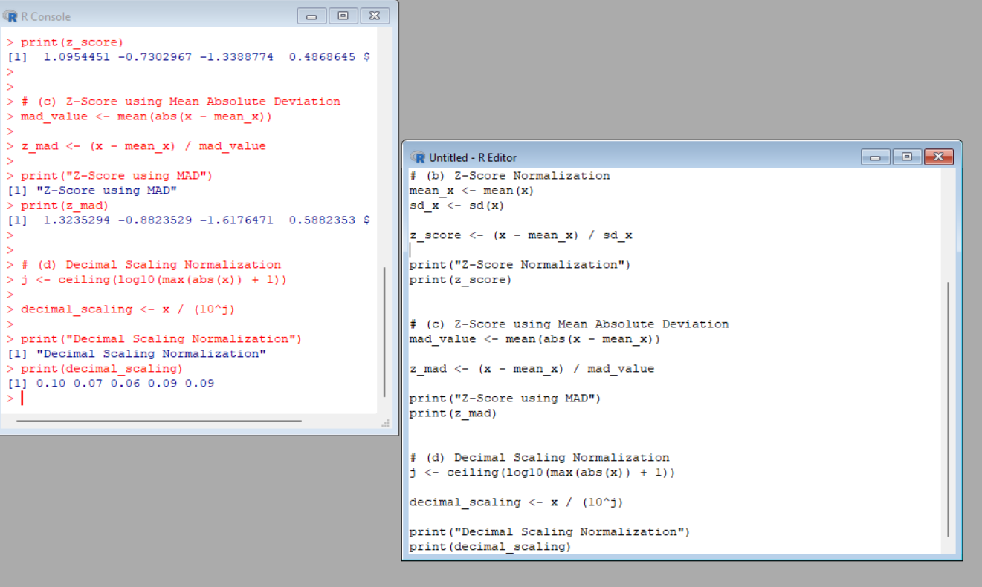
Q12 program:
# Data
AvgSpeed <- c(78,81,82,74,83,82,77,80,70)
TotalTime <- c(39,37,36,42,35,36,40,38,46)
# Standard Deviation
sd_speed <- sd(AvgSpeed)
sd_time <- sd(TotalTime)
print("Standard Deviation")
print(sd_speed)
print(sd_time)
# Variance
var_speed <- var(AvgSpeed)
var_time <- var(TotalTime)
print("Variance")
print(var_speed)
print(var_time)
output:
